**GIT REMOTING**

**Section 3(PUSHING ASSIGNMENTS TO REMOTE REPOSITORY)**

Logging into GITHUB Account

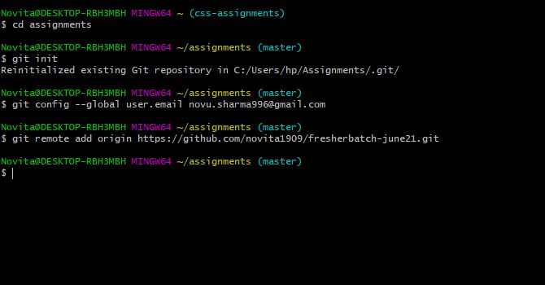

Pushing the assignments directory to public repository “freshersbatch-june21”

